Before being a progressive newspaper company, The Leader of Clinton County, the owners of The Leader were motor company owners. The motor company, Tinnen Motor Co. was one of Plattsburgh’s car dealerships and repair shops. In 1895, the newspaper began to be distributed. The newspaper company was owned by a different family than the Tinnen Motor Co.; that changed around 1969 when they purchased the right to the paper; to this day they have been the owners of it. Years after buying the paper, the Tinnen Motor Co. building was renovated and is now the Tinnen Town Hall Event Center.
The Leader, strategized a different way to distribute their newspaper. They are a “no throw” newspaper company, which mean that they do not have someone who drives or rides their bike and throws their paper at their front porch. Instead, The Leader has 2,000 print subscribers which is sent to the subscribers via U.S. mail. This method of distribution has been and will continue to affect the company in both a positive and negative aspect. This method of “no-throw” is a positive method because they now currently distribute newspaper to three different towns. The “no-throw” method of distribution could affect the cost efficiency of the company. Having someone deliver their newspaper for them would cost the company due to them having to pay salary or hourly plus mileage, especially if traveling out of town. This method could also affect the company because the cost of postage itself has been increasing throughout the years. Depending on when the company puts them through the post office, this could also affect the delivery time of the newspaper, especially if USPS does not work on Sundays or holidays. This is one of reasons why they want to move to posting their stuff online and rely less on mail. Something positive regarding the method of “no-throw” is that it is protected from extreme weather condition such as rain, snow or wind.
What also makes them different than other newspapers are that they are a weekly edition newspaper and not daily edition. this would mean that they only report what happened weekly and not every day. This in its self can be difficult because everyone’s going to find out the information way before they get the paper. There is also and advantage to this. when something where to happen, everyone going to be rushing, trying to be the first Newspaper to cover it. But sense they are weekly it already been cover multiple times. What they can do is ask people what they think and get reactions because sense it’s already been covered by everyone they can get reactions and be able to cover it and show what people’s reactions to it are. They also have a 8,000 shopper which is shopping adds that local stores and put in the paper. They have a smaller paper that go with their paper and its filled with coupons and other deals that they are offering.
Everything that is being offered cost 35 dollars a year which is a great deal compared to their competitors. For a year subscription for Kirksville daily express it’s 79.99 a year. They are basically giving away their papers at this point. But what they are wanting and need to do is focus on moving some if not most of their assets to online news. Which they already know and are slowly leaning and trying. Everything that was stated is from where they started all the way to what they are today. Most papers today are struggling because of social media and online presents. If businesses not matter what they are don’t keep up an online present, then newer generations and some older generations won’t pay attention to them. But that’s why we are here to help them out and try everything to get them back on to their feet and or give them a good foot in the door to social media.
The Clinton county leader has a lot of strengths and weaknesses. This is because of the changes over the years. Technologies has grown so big it’s effecting every business and it is very visible in the newspaper. In a SWOT analyses the strengths of what the leader has done can be seen by their successes which is very important. One of their greatest successes would be that they Bring the three communities together: Plattsburg, Lathrop, and Gower. they cover all three of these towns at the same time. It’s amazing how much this bring the community together. Their faculty consist of people for each of the towns which makes it easy for them to keep taps and write about what’s going on in their towns. They are small towns everyone loves to hear about their high school sports team which the leader loves talking about. another strength is that when they put on an event at their Town Hall they get people excided for it and have a lot of the community come out to be a part of it. example they are having and Easter evet here they are having all three of the towns sheriffs and there giving away toys to kids and let them play with the K-9’s. this is just one even that they did have done.
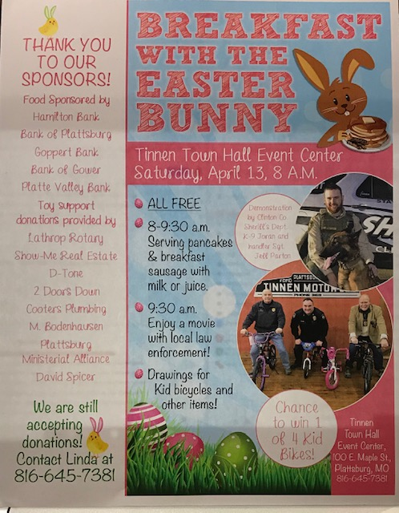
More strengths they have is having good amount of print sales their current sells as stated before is 80,000 current print, that is a good number for the them. and sense they are wanting to move more towards online it will only help their subscriptions grow bigger.
Even though they have strengths they also have weaknesses. The biggest weakness to the Leaders is there online presences in general. Their website has stated that it is being shut down for almost a year now. And they haven’t been posting in information about events that are happening or anything. Their Facebook and twitter are rarely use at all. The last post they ever made on their twitter was back in 2017. In this current age and generation an online present means everything. Not having a present really hurt the company. People are involved with social media that is would be a waste not to use it. Even if they did use it wouldn’t matter because the website being down. And lastly the two weaknesses would be only getting the same amount of people to show up at events and bad event scheduling. Even though they have good events they sometimes plan it on other events going on in town making it hard for people to come out
The opportunities and threats are that they are that the population they are writing for are mostly older generations and small-town people. They love seeing their kids on the front page and all but the kids themselves only want to see themselves online. And that’s where other newspaper can step in that have an online present and get more people to come to them. where as the Leader is lacking. But their opportunities are there too. They have their own event hall where they can put on evens and social gathering to get people to come out. also, they have a great well-rounded staff that are willing to try and learn new things to better the newspaper.

The people that the leader is trying to target is anyone that what is interested and can read the news. It doesn’t matter what age they are or who they are if they want to read it that’s who they are after. The big deal is that their target market is everyone but because of there they live it mostly only reaches older generation and with the younger generation only wanting to read digital it really puts them in a bind. That why they are wanting to reach out for help and learn how to post more thing on online then move more towards staying online. The people who read the paper are small-town people. They are close to one another and live to watch their schools play sports. They love to see their grandkids or kids on the front page making the game winning touch down or free throw. we recommend them to start posting videos of their kids making the shots online or even doing shot out to people who did so good they are going to state. We also recommended them to try and ask the automotive dealers if they would like to advertise on their website. This was because the dealers had ad’s in their paper a while back. And they could see that everything was going digital now, so they pulled their ad’s from the paper. But know sense we are helping them get their website going and online presents going they might be able to get them back again

